Reflection Agent basic core concept: AI improving by learning from mistakes. They use self-improvement. They are designed to analyse performance critically.
Three types of Reflection Agents: 1. Basic Reflection Agent 2. Reflexion Agent 3. Language Agent Tree Search or LATS
Let us understand Basic Reflection Agent with the help of an example where the prompt is: “How do I look cool?”
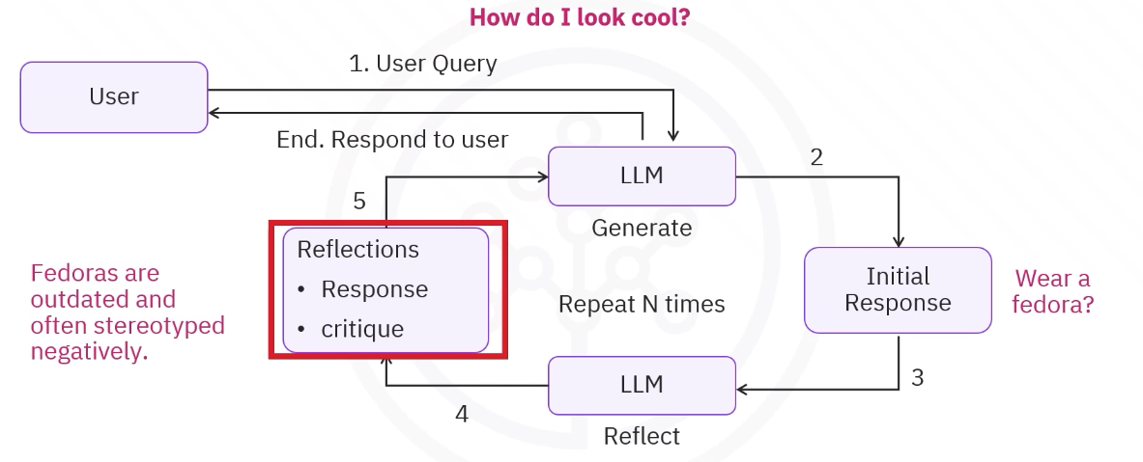
It will activate two LLMs, one will generate and the other will ‘reflect’(evaluates and critiques). Now Generator will say “Wear a Fedora” ​The reflector evaluates and critiques it. ​Fedoras are outdated and often stereotyped negatively. ​This loop runs for a set number of steps, refining the response before returning the ​final answer.
For the 2nd iteration generator based on the critiques and evaluation will generate another response :
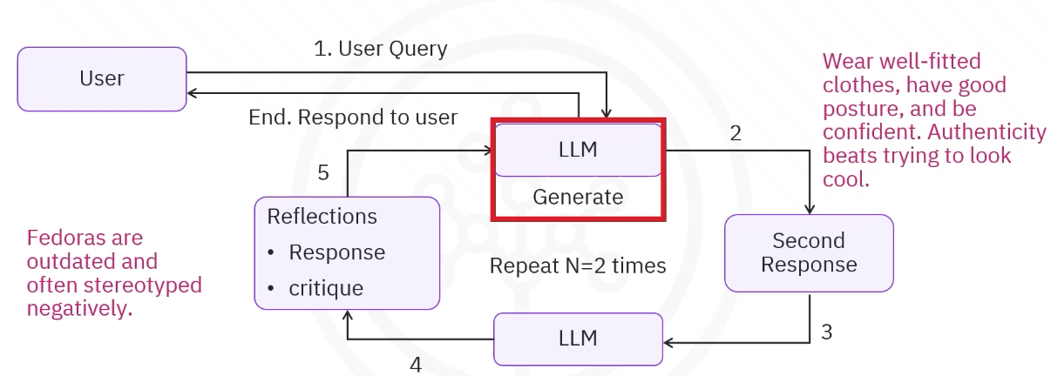
Again the reflector will evaluate the response and tell 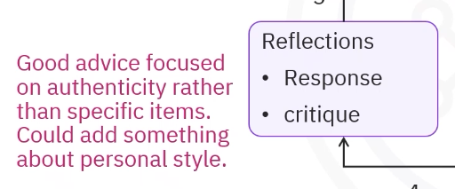
Then finally the generator provides the final output:
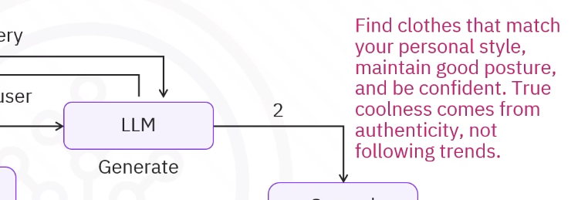
-----------------------------------------------------------------------------
NOW LETS BUILD A LINKEDIN POST OPTIMISATION AGENT WITH REFLECTION:
​In this example, you'll use IBM's Granite model via LangChain. ​To guide the generator LLM, use LangChain's chat prompt template. ​A SystemMessage defines the LLM's roles.
generation_prompt = ChatPromptTemplate.from_messages([
("system", "You are a helpful assistant, generate good blab la content and more bla bla"),
MessagesPlaceholder(variable_name="message"),
])
generate_chain = generation_prompt | llm

Similarly for Reflector LLM:
reflection_prompt = ChatPromptTemplate.from_messages([
("system", "You are a professional LinkedIn content strategist, your task is to critique evaluate post and provide a comprehensive critique."),
MessagesPlaceholder(variable_name="message"),
])
reflection_chain = reflection_prompt | llm
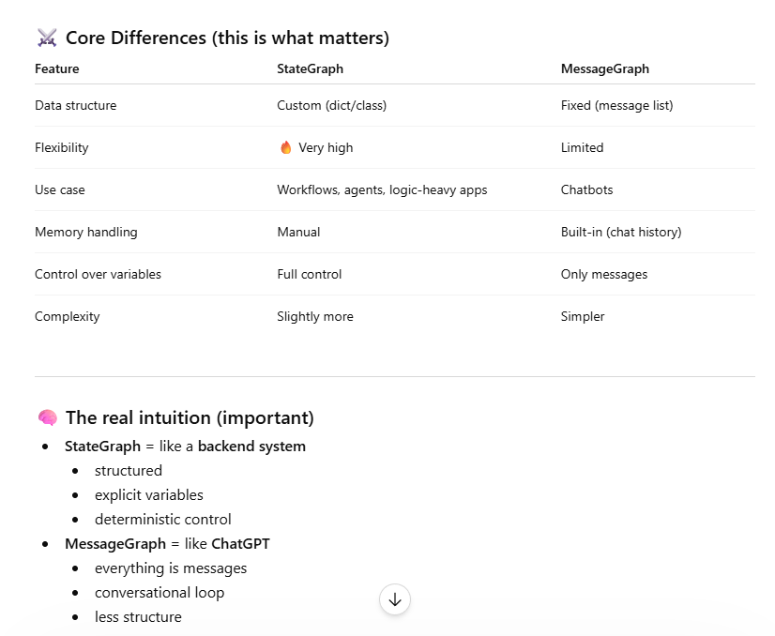
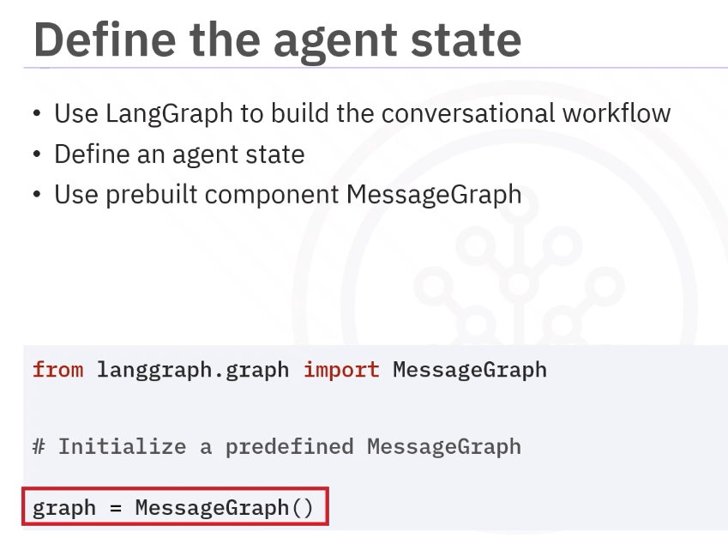
​LangGraph simplifies this with MessageGraph, a special graph type whose state holds only ​an array of messages, such as HumanMessage, AIMessage, SystemMessage. ​Think of MessageGraph as a specialized state graph that accumulates different message types.
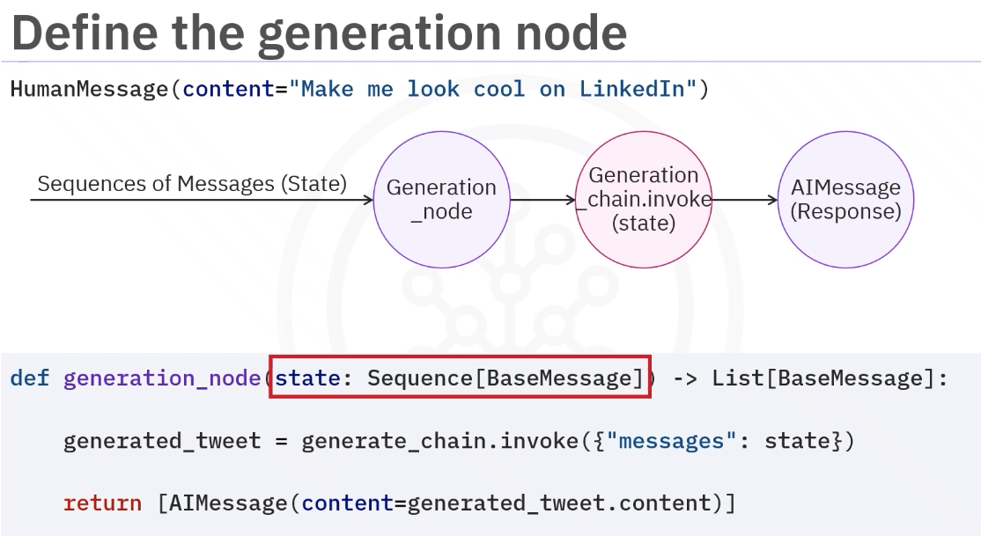
​The tool takes and returns a list-like object of BaseMessages. ​The generate node takes the state variable as input including the original HumanMessage, ​make me look cool on LinkedIn.
​The input HumanMessage is passed to the invoke function as a state. ​The chain uses that context to generate a response, "Wear a fedora and sunglasses in ​your profile pic." ​Finally, the function returns the output, wrapped in an AIMessage, and ready for the ​next stage in the workflow. ​The state variable contains the input message as a list. ​When the node returns a response, it implicitly updates the state variable, appending the ​AIMessage. Here in the state only AI message will get appended that is why we are returning in AIMessage wrapper.

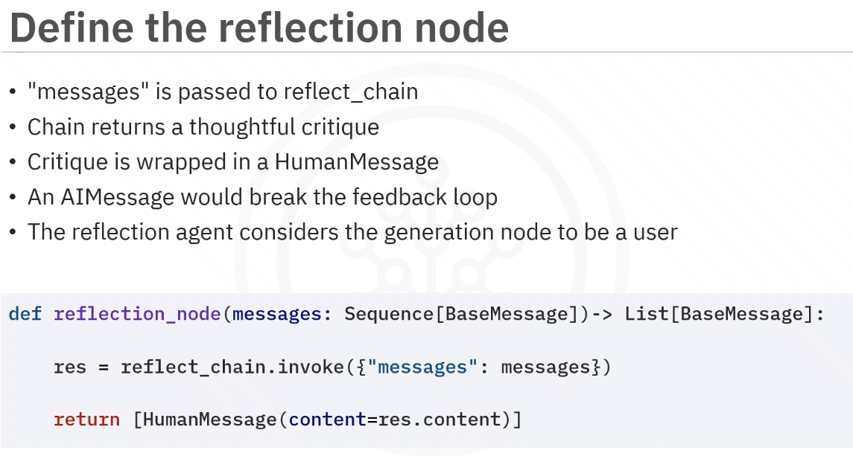

It takes in messages, a sequence of BaseMessage objects, and passes them into the reflect_chain. ​The chain returns a thoughtful critique of the last AI output. ​This critique is wrapped in a HumanMessage because generation_node expects ​human input; ​returning an AIMessage would break the feedback loop. ​By using HumanMessage, the reflection agent speaks to the generation node as a user, requesting ​refinement of the existing output. ​

